**SECTION 2 BUSINESS NEEDS:**

**Part 1: Problem statement:**

**Problem:**

In Britain, unequal compensation for comparable labor has been prohibited since the 1970s and is presently codified in the Equality Act 2010. Since 1997, the full-time pay difference has been shrinking over the years, and the total pay gap has also shrunk. Specifically, according to the most recent numbers disclosed under the government's gender pay gap reporting process in 2021, women in the UK were paid just 90p for every £1 earned by males[1]. However, there have also been recent reversals in this issue's development. The gender wage gap in the United Kingdom increased from 14.9% to 15.4% in 2021[2]. The pay gap continues because of deeply ingrained inequities in society and the economy.

**Impact:**

1. The increase in the gender pay gap can have a negative impact on companies’ competitiveness. Take women’s pay as an example, since women represent half of the global labor supply and around 70% of global consumer demand, a decrease in women’s pay results in poor loyalty and belief in the company’s value, lower their productivity, diversity, and gender balance of a company, which ultimately affects a company’s performance and position[3]. This problem not only affects the company tself, but also affects recruiters when hiring high-skilled workers and potential employees when choosing to join.
2. Besides, the gender pay gap can lead to a risk that all of the recent corporate gains may be jeopardized if employees continue to be disproportionately employed by gender, and obeyed the investor and stakeholder attention on the environment, social, and governance (ESG) strategy. ESG requires organizations to describe their position in society and how they are fair to their employees, suppliers, and communities. So, while the gender pay gap in the United Kingdom remains a relatively specific measure, companies are increasingly grappling with the challenge of contextualizing it in a broader conversation about social contribution.

**Timeframe, location, and trend:** The gender pay gap has always been an issue since women workers have taken up the battle for pay equity since the late 19th century. The dataset shows the data on the gender pay gap from different sizes of companies in the UK. In 2017, the UK government enacted legislation requiring organizations with 250 or more employees to report on their gender pay disparity on an annual basis. From 2017 to 2022, there is a slightly decreasing trend of the gender pay gap. Yet, the overall gender pay gap rose a bit in 2021 which might be affected due to COVID-19.

**Goal:** Improve the position and brand reputation of listed companies in the UK for the next 5 years by offering professional suggestions to reduce the gender pay gaps and attract more talent for greater social accountability.

**Vision(long term):** In general, there is little evidence regarding the temporal persistence of reputational damage or benefits. A later study by Gallemore, Maydew, and Thornock (2014) found that this negative shareholder effect reversed within a month. This suggests that the reputational effects of the disclosure may be short-lived[4]. **（limitation**）

**Importance**:

For **companies**:

1. **Recruiters** like **Chief Human Resource Officers (CHO)** can utilize expanded analysis and reporting to dive into their pay in order to discover the root causes of pay gaps and understand companies’ current position in the industry by evaluating past figures and trends. Also, CHO can develop more specific and effective strategies in the next financial years by evaluating the effectiveness and efficiencies of the past strategies relating to reducing gender pay gaps through changes in the industry position.
2. Bespoke suggestions are offered as an indication for CHO to develop HR-related strategies to improve the company’s position and align with the ESG criteria (satisfying shareholders), (also achieving their KPI) based on data and analysis by comparing firms with similar sizes and gender pay gap trends. For example, provide voluntary supplementary pay gap reporting for ethnicity, disability, and socioeconomic mobility.

For **employees/graduates/workers**:

1. Pay transparency provides **workers** with the information and evidence they need to negotiate pay rates and gives them a way to challenge potential pay discrimination. Encourages **current employees** to have a clear indication that they want to demonstrate their commitment to eliminating the gender pay gap and bolstering companies’ reputation as a fair and ethical workplace.
2. **Workers** are able to **choose** their preferred employer based on their willingness of pays, for example, workers can find out a company that is more female-friendly and has fewer gender pay gaps than others.

**Part 2**: **Target audiences (persona):**

Recruiters and workers

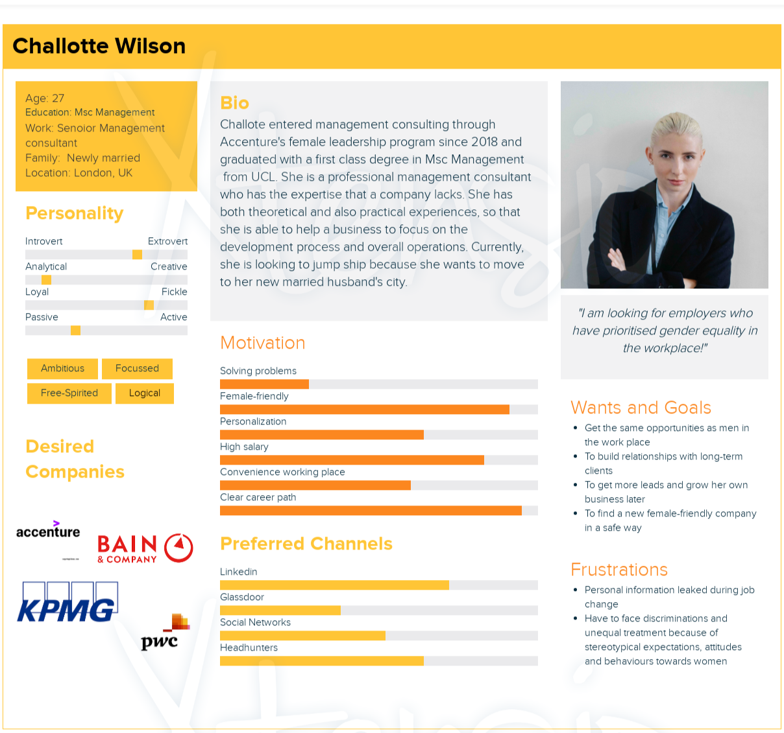

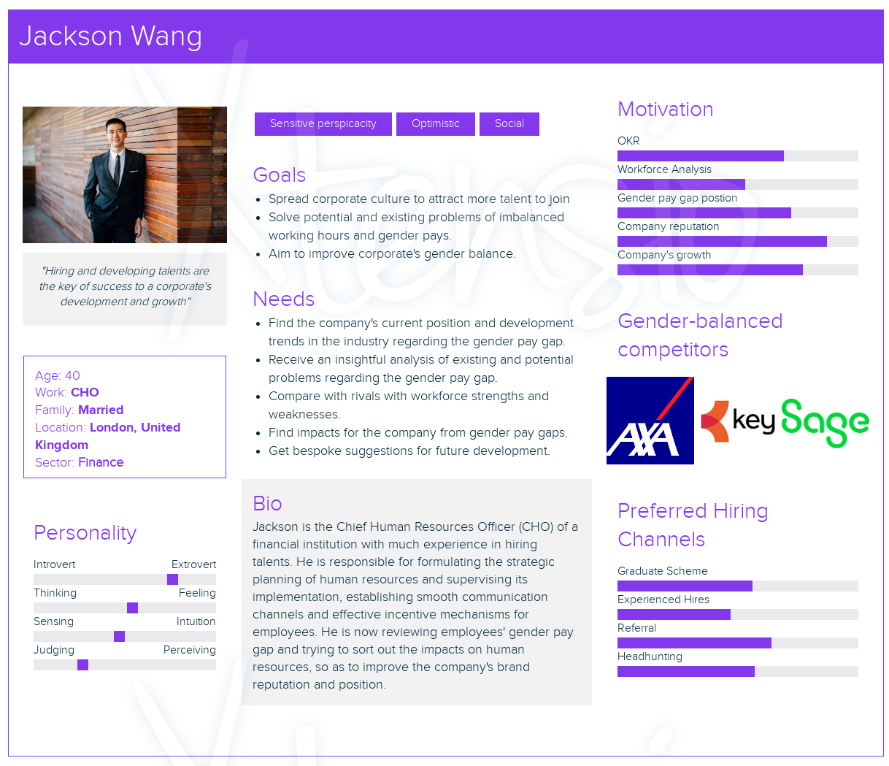

**Part 3: Questions:**

**For employees**/**graduates/workers** or people who are looking for a job or trying to know more about the company’s information.

* **Industry**

1. How **many industries** can we define from our datasets? （**maybe unnecessary**）
2. Which industries are having the **largest and the least mean gender pay gap** in both hourly pay and bonus pay in different years?
3. What are the **average** **gender pay quantiles** (including lower, lower middle, upper middle, and top) in these industries?
4. What are the **trends** for the gender pay gap (both hours and bonus pay) from 2017 to 2022 in different industries by comparing **both mean value and median value**?
5. What is the **percentage** of gender bonus pay in different years?
6. Are there any industries that are **women-friendly** in 2017 and 2022?
7. Can we predict the gender pay gap trend in 2023?

* **Company size**

1. **How many classes can we define based on the dataset? (**maybe unnecessary）
2. Based on different classes of companies' sizes, which classes are having the **largest and the least mean gender pay gap** in both hourly pay and bonus pay in different years?
3. What is the **percentage** of gender bonus pay in different years?
4. What are the **average** **gender pay quantiles** (including lower, lower middle, upper middle, and top) in these classes?
5. What are the **trends** for the gender pay gap (both hours and bonus pay) from 2017 to 2022 in different sizes by comparing **both mean value and median value**?
6. Can we find out whether a smaller firm size or a large firm size has less gender pay gap? Or **female-friendly** in different years from 2017 to 2022?
7. Can we predict the gender pay gap trend in 2023

**For companies: recruiters** who want to learn about the current position of their firm, **graduates** can also compare the pay of target companies.

* Individual companies

1. Trends in individual companies comparing performance with themselves: both **average and median differences** in **hourly** and **bonus** pay over the years, **percentage**s of bonus pay in gender, and **pay quantiles**(including lower, lower middle, upper middle, and top) over the years.
2. What is the **rank** in either the **industry** or **company size** by comparing the hourly pay gap and bonus pay gap?
3. Is the specific firm female-friendly? or has the firm improved a lot in solving the pay gap?
4. What is the **difference between the firm itself and its competitors**(with a higher ranking)

**Part 4. a suggestion for a machine learning model**

1. **Classification model?** To classify companies into their corresponding industries ( this function can be found on govuk.com)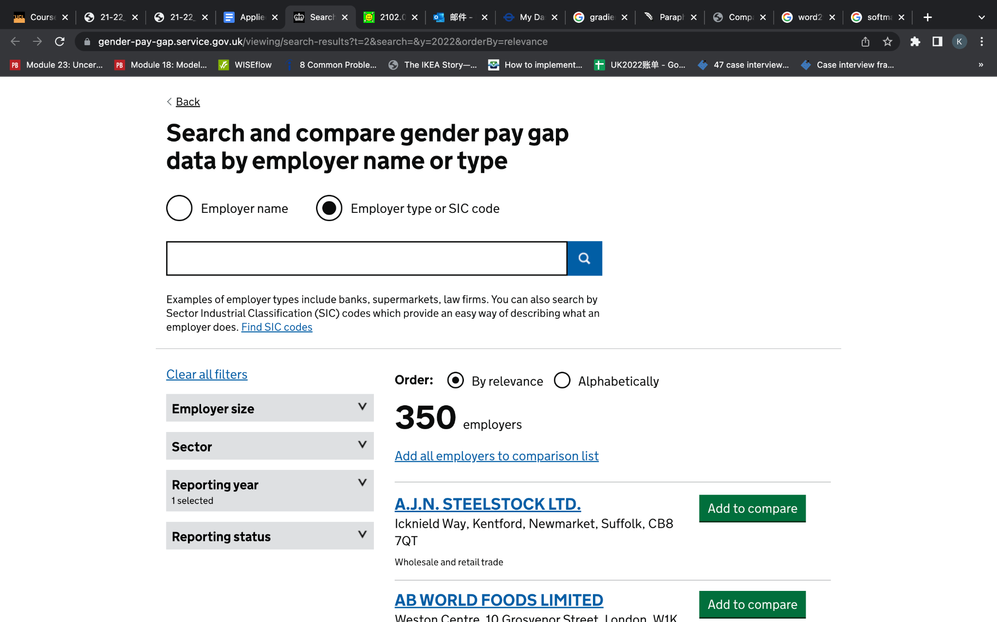
2. **Regression**: to **predict** future trends mainly in gender pay gaps based on previous data on these attributes: hourly pay gap, bonus pay gap, and percentages in gender pay of bonus.
3. **XGboost(**similar to a product matching model**)**: 1. For **graduates/employees** to compare gender pay gaps or mean gender pays with several companies. 2. For **the company( recruiters)** to use competitor analysis. Companies compare their pay for employees to their rivals’ and make quick responses to identify the gender pay gap they could lower to their range.

1. .<https://www.theguardian.com/world/2022/apr/06/uk-gender-pay-gap-women-paid-90p-for-1-earned-by-men>
2. .<https://www.ons.gov.uk/employmentandlabourmarket/peopleinwork/earningsandworkinghours/bulletins/genderpaygapintheuk/2021>
3. .<https://www.forbes.com/sites/forbestechcouncil/2019/07/26/how-the-gender-pay-gap-could-destroy-business-competitiveness/?sh=3ec30c7f68dc>
4. The Impact of Mandated Pay Gap Transparency on Firms’ Reputations as Employers <https://journals.sagepub.com/doi/full/10.1177/00018392221124614>